Machine Learning
Machine Learning (ML) is a branch of Artificial Intelligence where computers learn patterns from data and make decisions or predictions without being explicitly programmed for every task.
Instead of writing fixed rules, we give the computer:
- Data
- Examples
- Algorithms
The machine learns from the data and improves its performance over time.
Simple Example
If we show a computer thousands of emails marked as spam or not spam, it learns the pattern and can automatically identify spam emails in the future.

Types of Machine Learning
Machine Learning is mainly divided into 4 types.

1. Supervised Learning
In supervised learning, the machine is trained using labeled data.
Labeled data means:
- Input data already has the correct output.
The model learns the relationship between input and output.
Example
Input | Output
Study hours | Exam marks
Email text | Spam / Not Spam
Applications
- Email spam detection
- Weather prediction
- House price prediction
- Image classification
Common Algorithms
- Linear Regression
- Logistic Regression
- Decision Tree
- Support Vector Machine (SVM)
Diagram
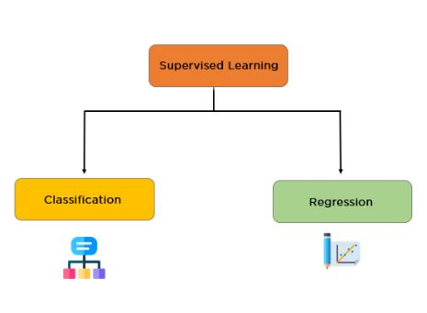
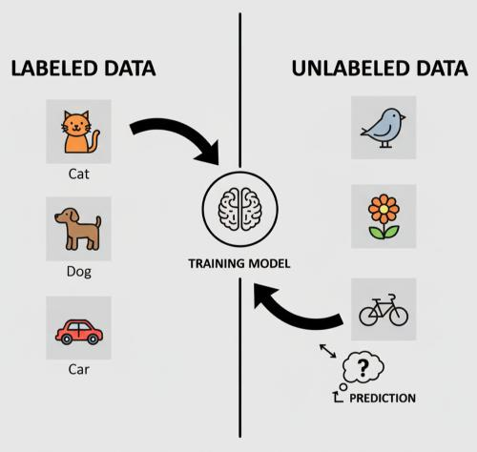
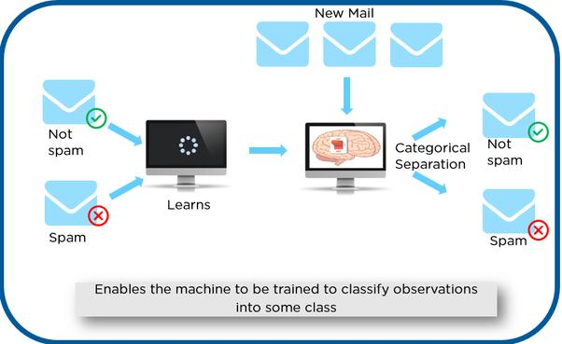
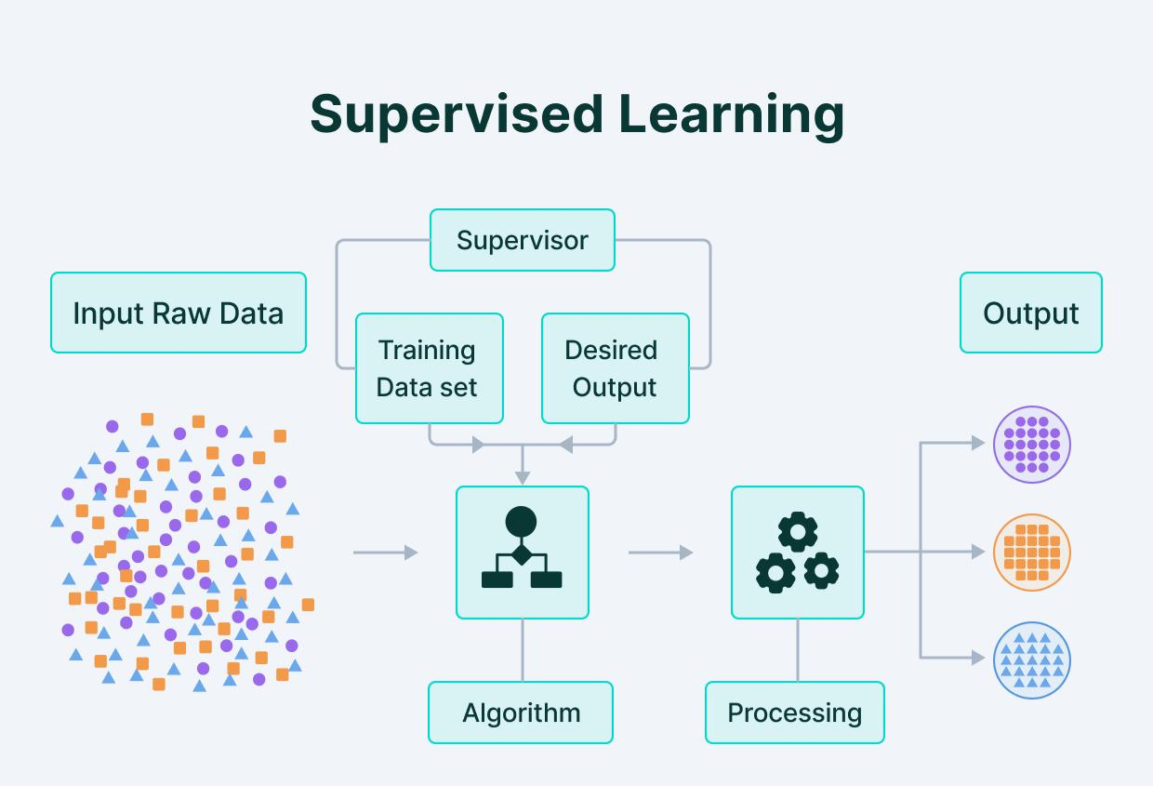
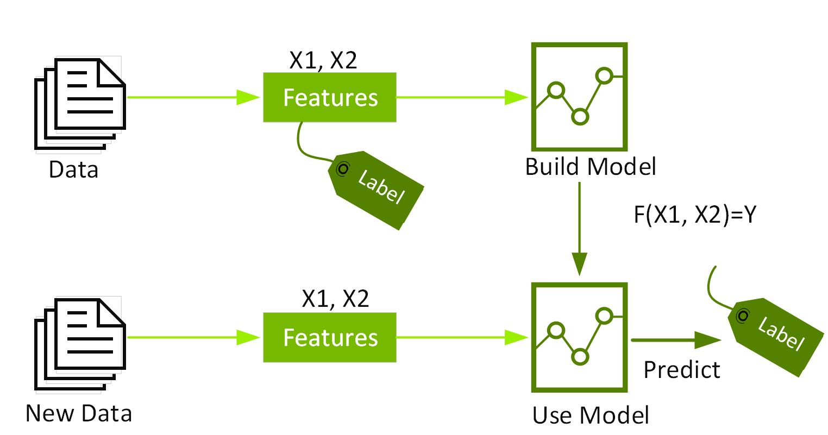
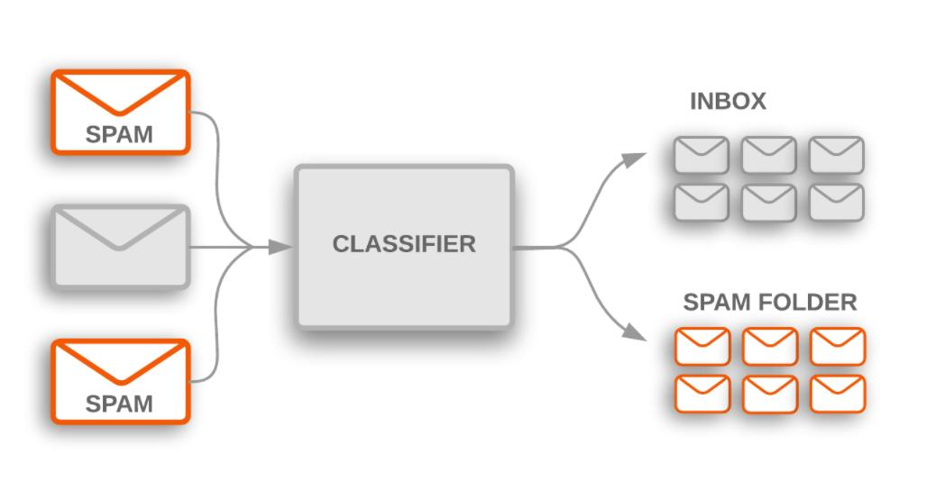

2. Unsupervised Learning
In unsupervised learning, the machine is trained using unlabeled data.
The system tries to find hidden patterns or groups by itself.
Example
A shopping app groups customers based on buying behavior.
Applications
- Customer segmentation
- Recommendation systems
- Pattern detection
- Data grouping
Common Algorithms
- K-Means Clustering
- Hierarchical Clustering
- PCA (Principal Component Analysis)
Diagram
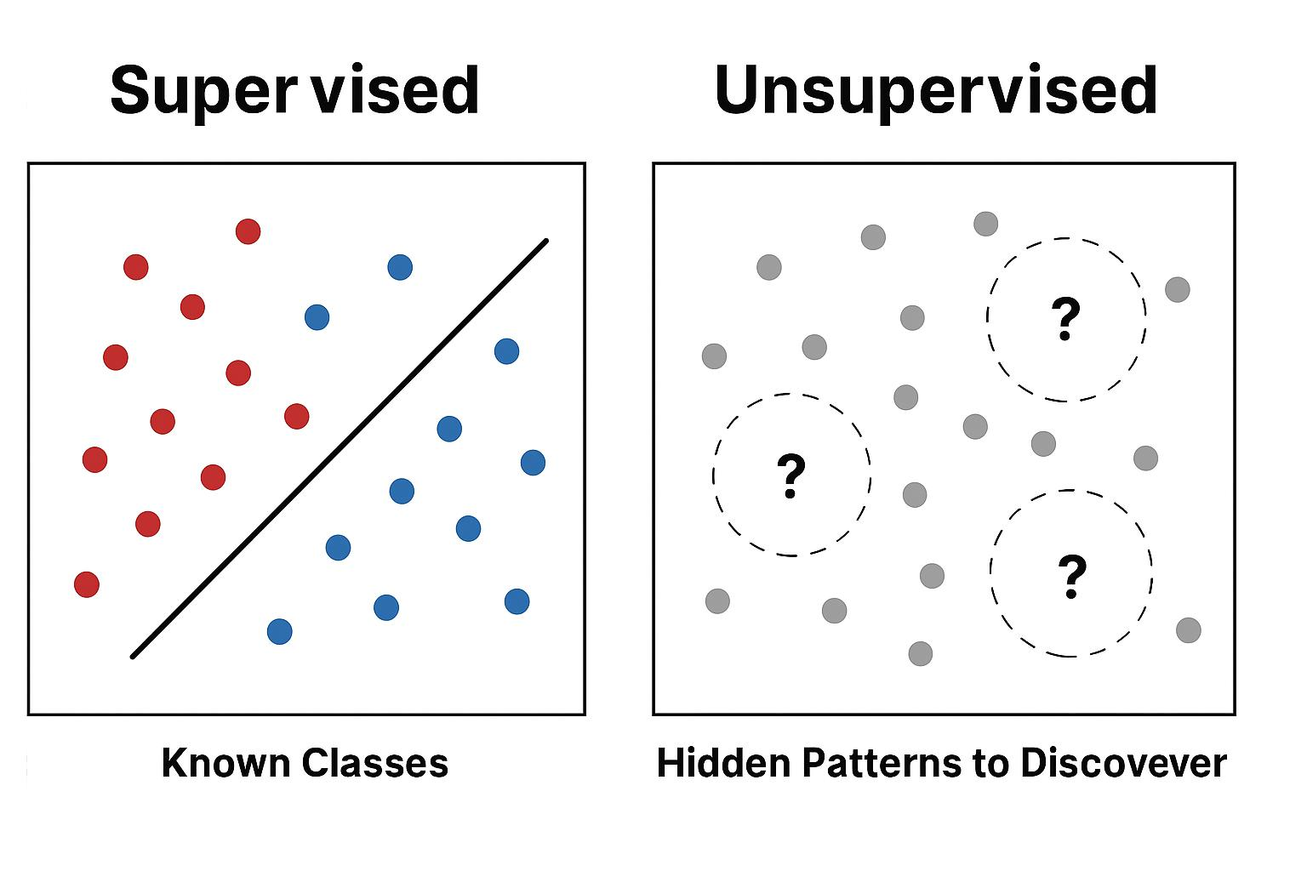
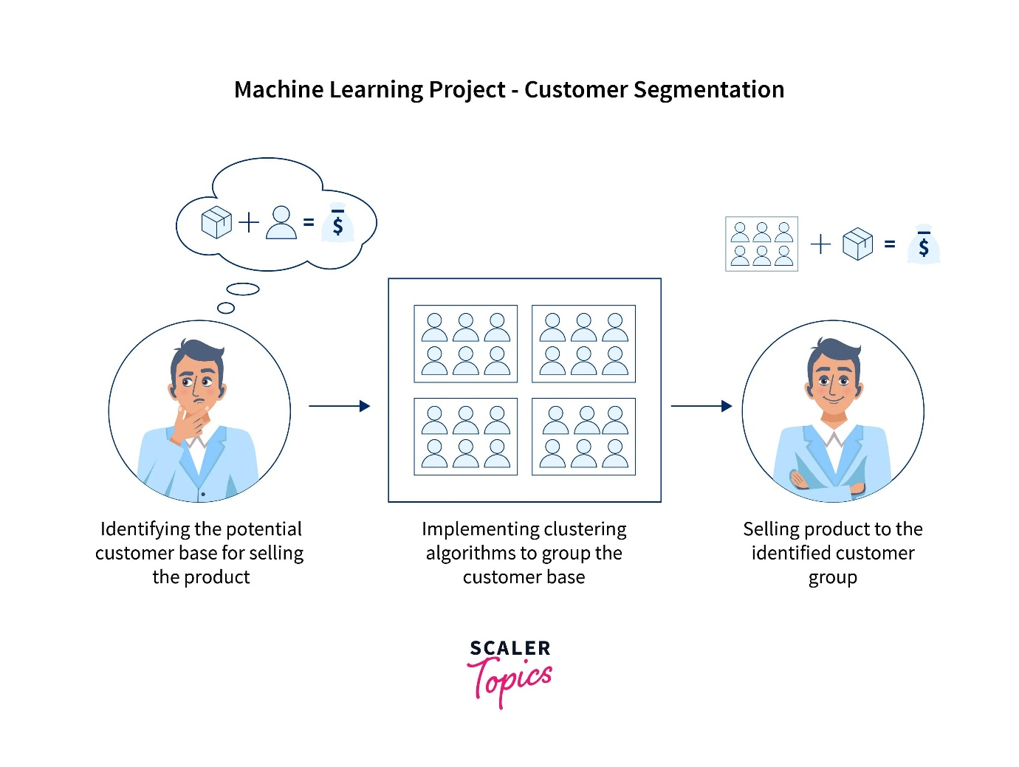
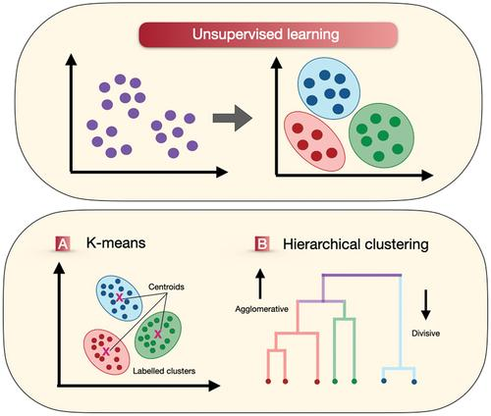

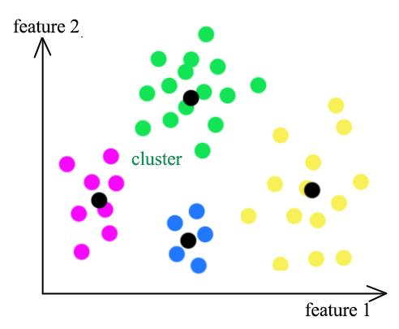
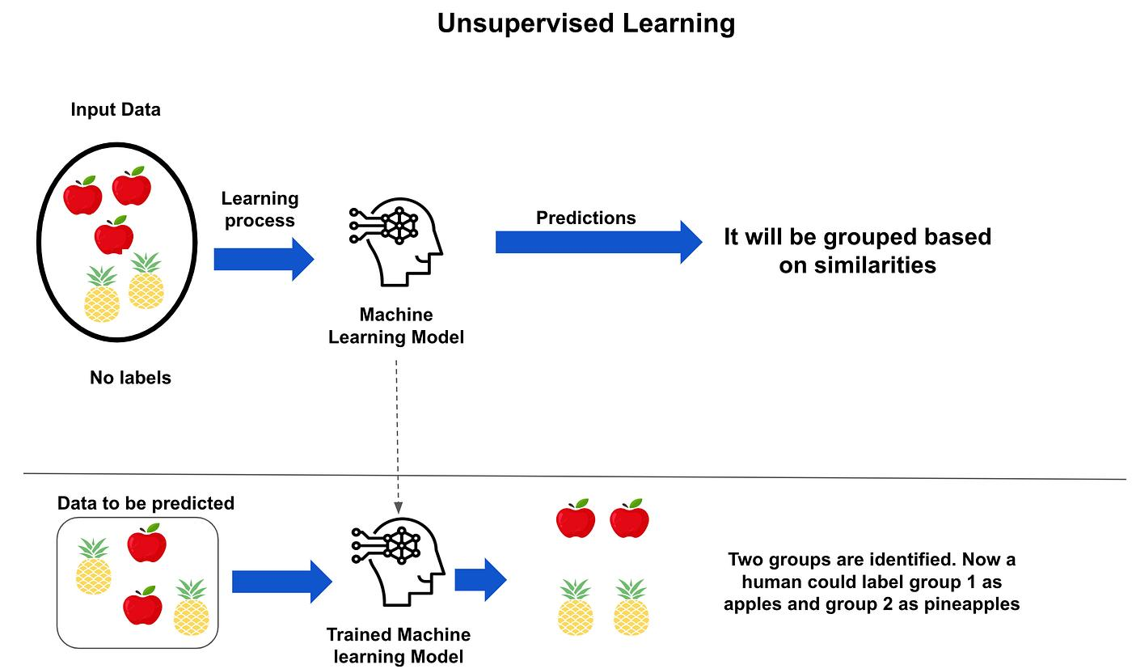

3. Reinforcement Learning
In reinforcement learning, an agent learns by:
- Performing actions
- Receiving rewards or penalties
The goal is to maximize the reward.
Example
A robot learns to walk by trying different movements.
Applications
- Self-driving cars
- Robotics
- Game playing
- AI assistants
Key Terms
- Agent
- Environment
- Reward
- Action
Diagram
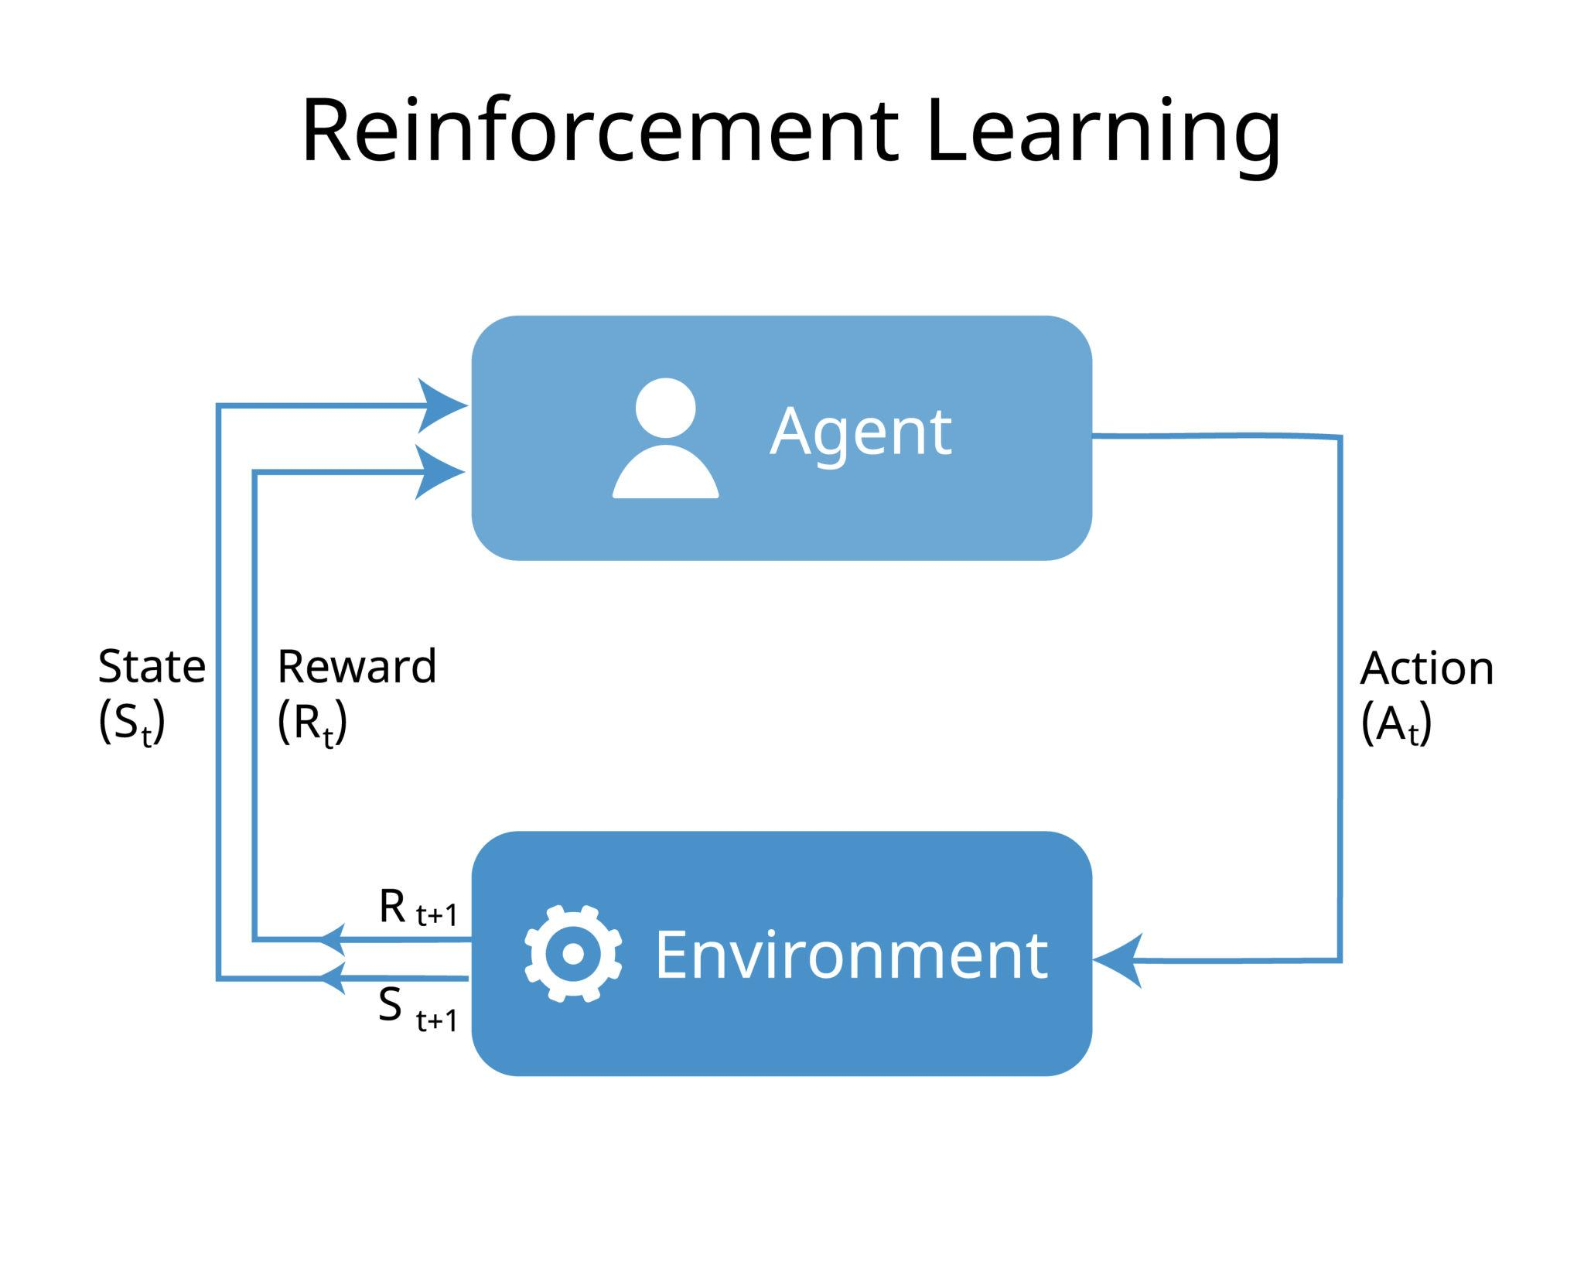
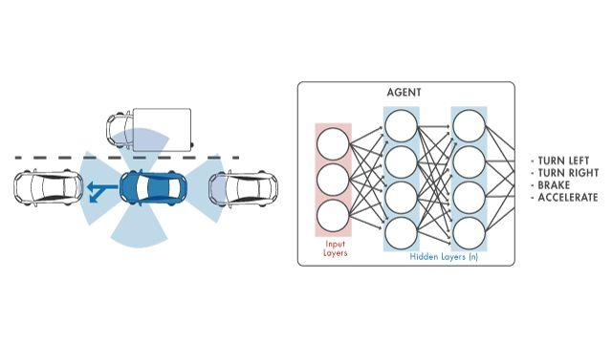
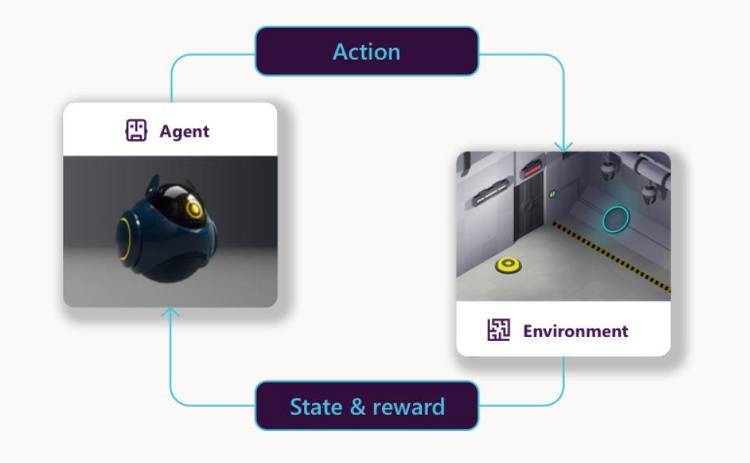
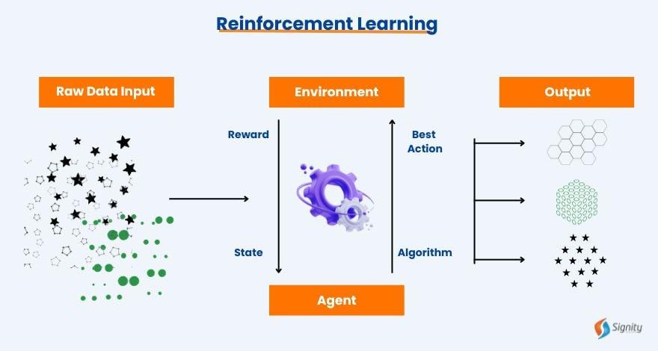
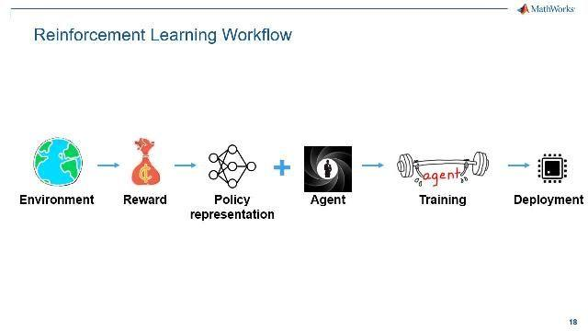
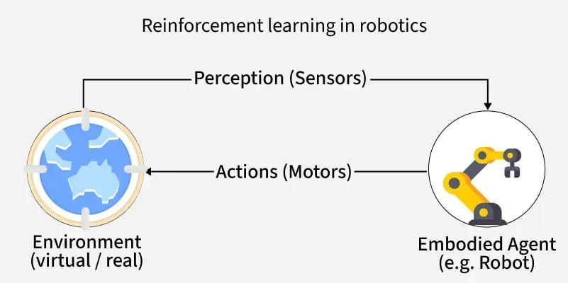

4. Semi-Supervised Learning
This combines:
- A small amount of labeled data
- A large amount of unlabeled data
It is useful when labeling data is expensive.
Applications
- Medical image analysis
- Speech recognition
- Web content classification
Diagram
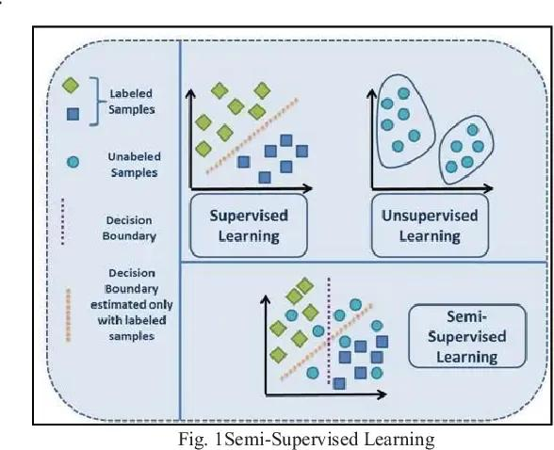
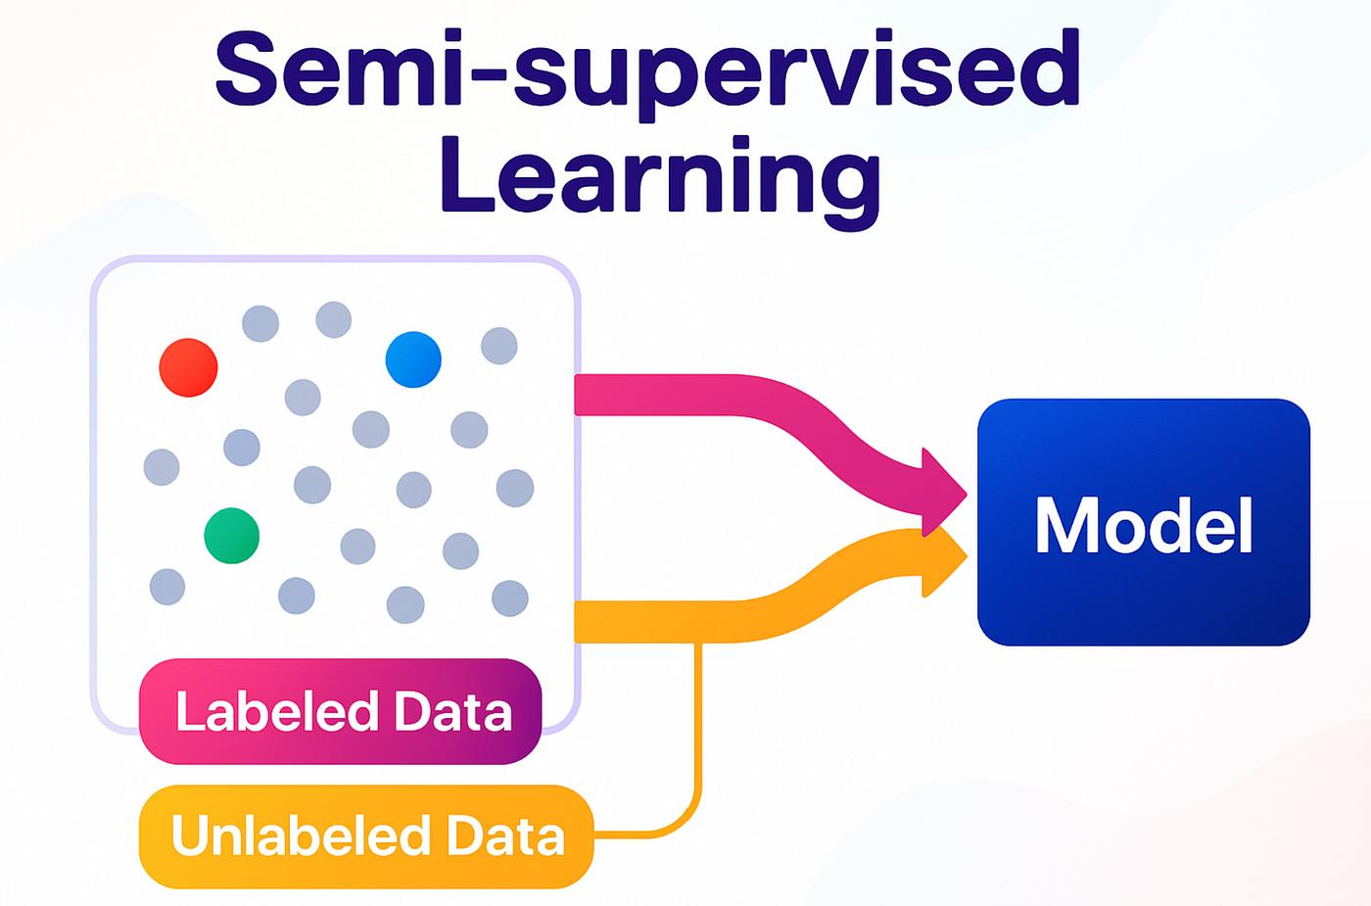
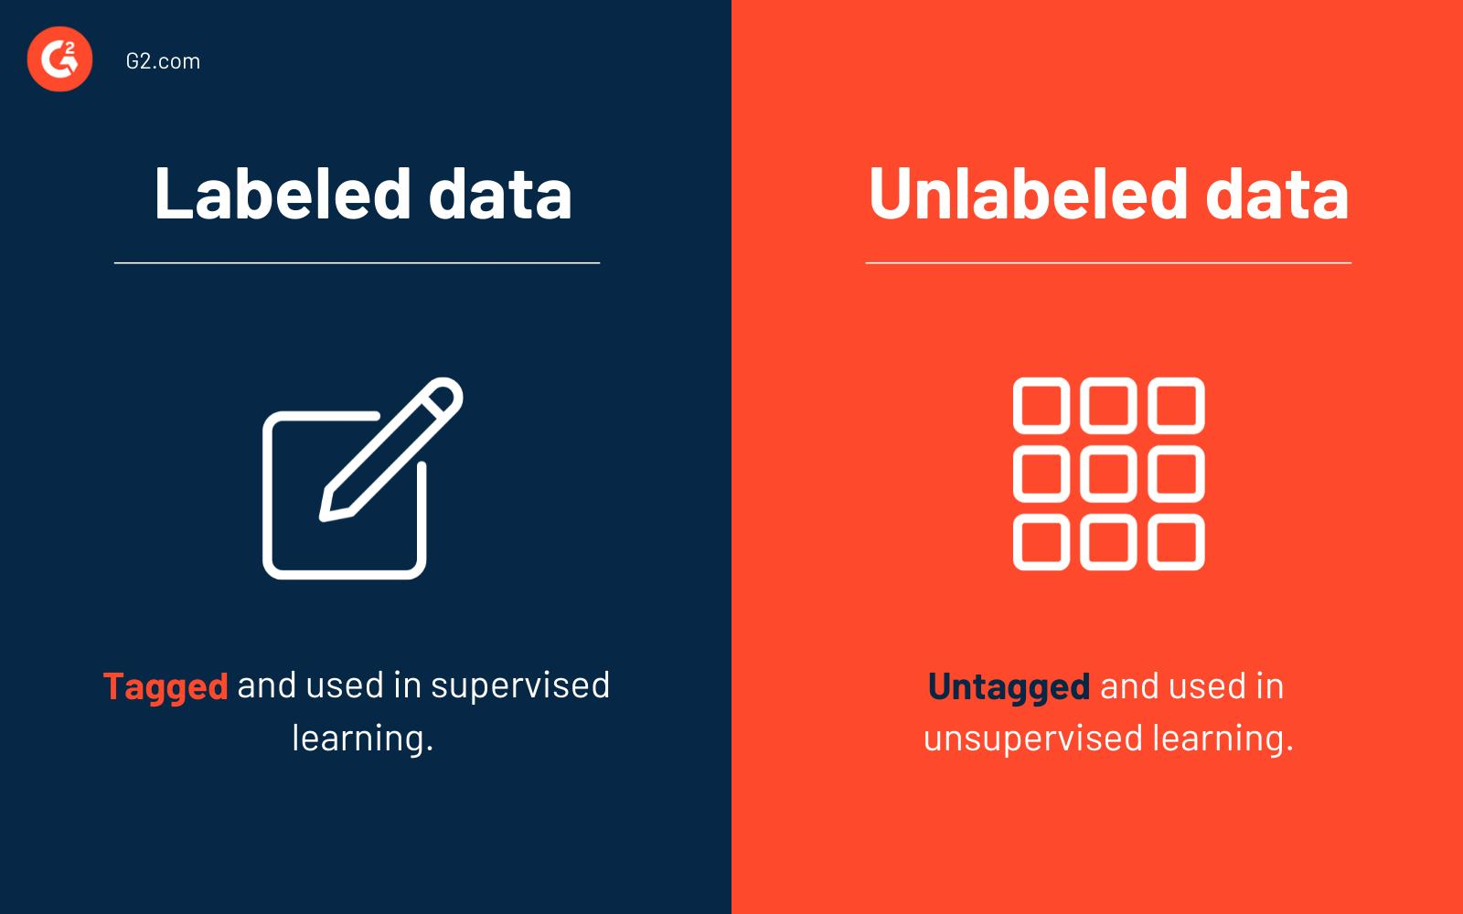
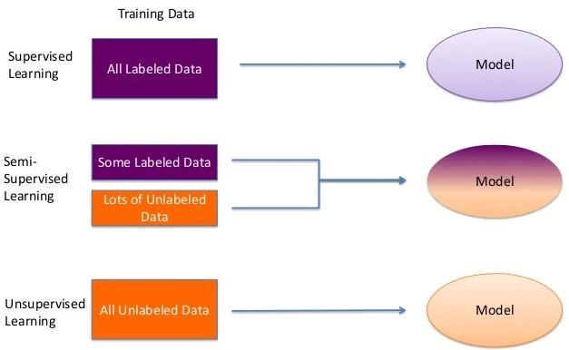

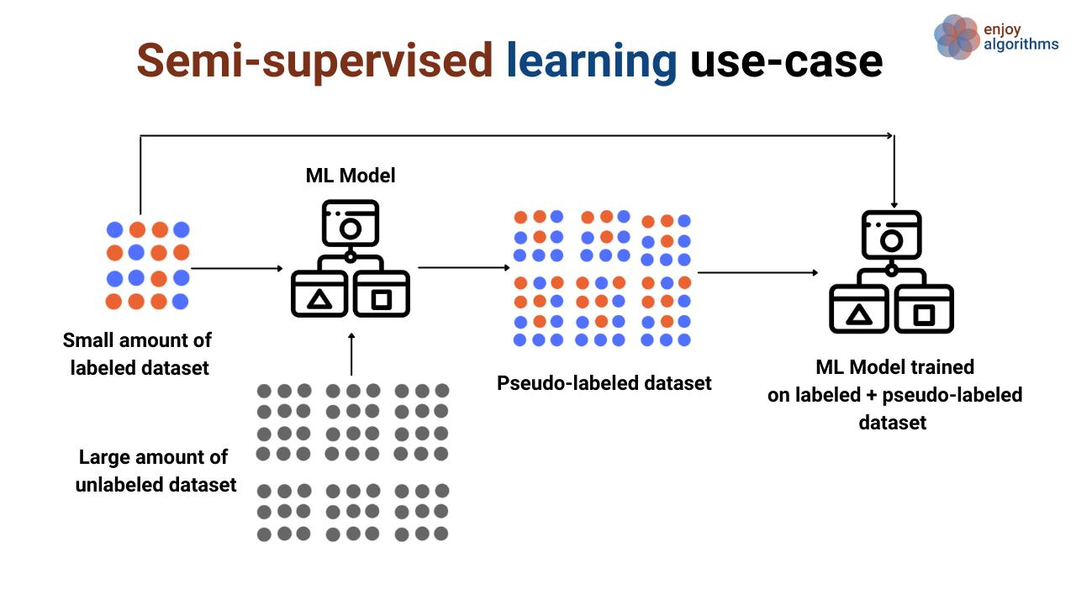

Comparison of Types
Type | Data Used | Main Goal
Supervised Learning | Labeled Data | Predict output
Unsupervised Learning | Unlabeled Data | Find patterns
Reinforcement Learning | Rewards & Penalties | Learn best action
Semi-Supervised Learning | Mixed Data | Improve accuracy with less labeled data

Advantages of Machine Learning
- Automates tasks
- Improves accuracy
- Handles large data
- Learns and improves over time
Disadvantages
- Requires large data
- Can be expensive
- Sometimes difficult to understand predictions
- Needs powerful computers for complex tasks

Real-Life Examples
- Netflix recommendations
- Google Translate
- Face recognition
- Chatbots
- Online shopping suggestions

Conclusion
Machine Learning enables computers to learn from data and make intelligent decisions. Different types of machine learning are used depending on the nature of the problem and the available data.
Machine Learning
Machine Learning (ML) is a branch of Artificial Intelligence where computers learn patterns from data and make decisions or predictions without being explicitly programmed for every task.
Instead of writing fixed rules, we give the computer:
- Data
- Examples
- Algorithms
The machine learns from the data and improves its performance over time.
Simple Example
If we show a computer thousands of emails marked as spam or not spam, it learns the pattern and can automatically identify spam emails in the future.

Types of Machine Learning
Machine Learning is mainly divided into 4 types.

1. Supervised Learning
In supervised learning, the machine is trained using labeled data.
Labeled data means:
- Input data already has the correct output.
The model learns the relationship between input and output.
Example
Input | Output
Study hours | Exam marks
Email text | Spam / Not Spam
Applications
- Email spam detection
- Weather prediction
- House price prediction
- Image classification
Common Algorithms
- Linear Regression
- Logistic Regression
- Decision Tree
- Support Vector Machine (SVM)
Diagram







2. Unsupervised Learning
In unsupervised learning, the machine is trained using unlabeled data.
The system tries to find hidden patterns or groups by itself.
Example
A shopping app groups customers based on buying behavior.
Applications
- Customer segmentation
- Recommendation systems
- Pattern detection
- Data grouping
Common Algorithms
- K-Means Clustering
- Hierarchical Clustering
- PCA (Principal Component Analysis)
Diagram







3. Reinforcement Learning
In reinforcement learning, an agent learns by:
- Performing actions
- Receiving rewards or penalties
The goal is to maximize the reward.
Example
A robot learns to walk by trying different movements.
Applications
- Self-driving cars
- Robotics
- Game playing
- AI assistants
Key Terms
- Agent
- Environment
- Reward
- Action
Diagram







4. Semi-Supervised Learning
This combines:
- A small amount of labeled data
- A large amount of unlabeled data
It is useful when labeling data is expensive.
Applications
- Medical image analysis
- Speech recognition
- Web content classification
Diagram







Comparison of Types
Type | Data Used | Main Goal
Supervised Learning | Labeled Data | Predict output
Unsupervised Learning | Unlabeled Data | Find patterns
Reinforcement Learning | Rewards & Penalties | Learn best action
Semi-Supervised Learning | Mixed Data | Improve accuracy with less labeled data

Advantages of Machine Learning
- Automates tasks
- Improves accuracy
- Handles large data
- Learns and improves over time
Disadvantages
- Requires large data
- Can be expensive
- Sometimes difficult to understand predictions
- Needs powerful computers for complex tasks

Real-Life Examples
- Netflix recommendations
- Google Translate
- Face recognition
- Chatbots
- Online shopping suggestions

Conclusion
Machine Learning enables computers to learn from data and make intelligent decisions. Different types of machine learning are used depending on the nature of the problem and the available data.

